DESIGN AND CONFIGURATION OF A SIMPLE NETWORK TOPOLOGY USING ONE ROUTER, TWO SWITCHES, AND PCS IN CISCO PACKET TRACER
EXPT: 10
AIM:
To design and configure a basic network topology consisting of one router, two switches, and multiple PCs in Cisco Packet Tracer, and to verify successful communication between the connected networks.
INTRODUCTION:
In computer networking, routers are used to connect different networks, while switches connect multiple devices within the same local area network (LAN).
In this experiment, two LANs—each connected through a switch—are interconnected via a router. Each LAN will be assigned a unique IP address range, and the router will enable packet transmission between them.
ALGORITHM:
- Open Cisco Packet Tracer.
- Select and place the following network devices:
  - 1 Router (e.g., Cisco 2911)
  - 2 Switches (e.g., Cisco 2960)
  - 4 PCs
- Connect the devices using Copper Straight-Through cables as follows:
  - PC0 → Switch0 (FastEthernet0/1)
  - PC1 → Switch0 (FastEthernet0/2)
  - PC2 → Switch1 (FastEthernet0/1)
  - PC3 → Switch1 (FastEthernet0/2)
  - Switch0 → Router (GigabitEthernet0/0)
  - Switch1 → Router (GigabitEthernet0/1)
- Assign IP addresses to the PCs:
  - LAN 1 (Switch0 side): 192.168.1.0/24 → PC0, PC1
  - LAN 2 (Switch1 side): 192.168.2.0/24 → PC2, PC3
- Configure the router interfaces:
  - Interface GigabitEthernet0/0: IP 192.168.1.1 255.255.255.0
  - Interface GigabitEthernet0/1: IP 192.168.2.1 255.255.255.0
  - Use the command no shutdown to activate both interfaces.
- Set the Default Gateway on each PC:
  - For LAN1 PCs → 192.168.1.1
  - For LAN2 PCs → 192.168.2.1
- Verify the configuration:
  - Use the ping command from a PC in LAN1 to a PC in LAN2.
  - Check for successful reply messages.
- If packets are received successfully, the network setup is verified and functional.
NETWORK TOPOLOGY:
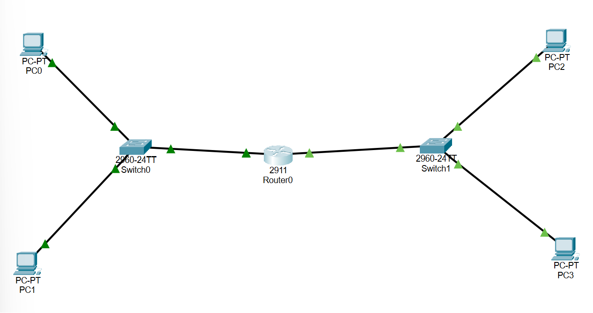

OUTPUT:
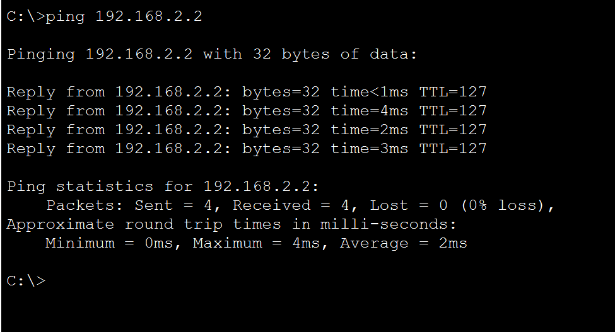
RESULT:
A simple network topology using one router, two switches, and multiple PCs was successfully designed and configured in Cisco Packet Tracer. Communication between both LANs was verified through the ping command.

